1.[Root mean squared error](https://en.wikipedia.org/wiki/Root-mean-square_deviation): It  is the most popular metrics used in Regression problems.RMSE is defined by the standard deviation of prediction errors. These prediction errors are sometimes called Residuals. Residuals are basically the measurement of the distance of data points from the Regression line.

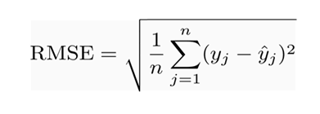

**Where**:

* Σ = [summation](https://www.statisticshowto.datasciencecentral.com/summation/)(“add up”)
* (yi— yj)Sup>2 = differences, squared
* N = [sample size](https://www.statisticshowto.datasciencecentral.com/probability-and-statistics/find-sample-size/)

**2. Mean** *Absolute* **Error** The Average taken between the original values and predicted values is called [Mean Absolute Error](https://scikit-learn.org/stable/modules/generated/sklearn.metrics.mean_absolute_error.html#sklearn.metrics.mean_absolute_error). It also measures the average magnitude of error i.e. how far the predictions from the actual output. Moreover, MAE does not provide us any direction of error i.e. whether we are overfitting the data or under fitting the data.

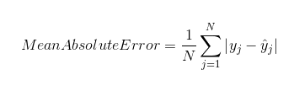

**3. Mean Squared Error:** There is a minor difference between [MSE](https://scikit-learn.org/stable/modules/generated/sklearn.metrics.mean_squared_error.html#sklearn.metrics.mean_squared_error) and MAE. Deviation comes in MSE takes the average of the **square**of the difference between the original values and the predicted values. In MSE computation of gradient becomes easier than MAE which requires computational tools in order to compute gradients.

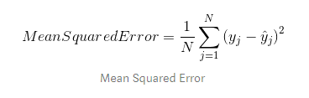

Mean Squared Error is good to use when the target column is normally distributed around the mean value. Mean squared error comes into the picture when outliers are present in our dataset and it becomes necessary to penalize them.

**4. R Squared/Adjusted R Squared:** [R squared](https://scikit-learn.org/stable/modules/generated/sklearn.metrics.r2_score.html#sklearn.metrics.r2_score) is a statistical measure of how close the data point is fitted to the regression line. It is also known as the coefficient of determination-Squared is defined by the explained variation divided by total variation that was explained by the linear model.

**5.Mean absolute percentage error (MAPE):**It is a statistical measure of how accurate a forecast system is measured. It describes this accuracy as a percentage, and can be calculated as the average absolute percent error for each time period minus actual values divided by actual values. Where At is the actual value and Ft is the forecast value, this is given by:

https://www.statisticshowto.com/wp-content/uploads/2017/09/mape.jpeg